ST10089515 Motjoka Fanana CLDV6212 POE PART 1

A.

|  |  |  |  |
| --- | --- | --- | --- |
| Traditional On-Premises | | Modern Cloud | |
| On-premises definition | On-premises example | Cloud definition | Cloud example |
| Monolithic: A monolithic architecture refers to an application that is built as a single, tightly integrated unit where all components and functionalities are tightly coupled together. | Monolithic:  Consider a traditional on-premises enterprise application consisting of a single codebase for the user interface, business logic, and database access. The application runs on a dedicated server in the company's own data center. Any update or change to any part of the application may require a change to the entire monolith. | Decomposed: A decomposed architecture, often referred to as a microservices architecture, involves breaking down an application into smaller, loosely coupled services that can be developed, deployed, and managed independently. | Decomposed: In a cloud environment, a decomposed architecture may involve deploying each microservice as an individual container using container platforms such as Docker or Kubernetes. Each microservice can be scaled independently, allowing the application to efficiently handle different levels of traffic. For example, a video streaming platform may use separate microservices for user authentication, content delivery, and payment processing. |
| Designed for predictable scalability:  On-premises deployment involves hosting applications on proprietary infrastructure in a physical location, for projected and planned growth. | Run an on-premises mail server in the organization's data center; Deploy applications on dedicated local servers. On-premises systems require upfront hardware provisioning, which limits the ability to scale quickly; Expansion involves buying and setup time. | Modern cloud (designed for elastic scale):  Modern cloud deployments use third-party cloud services for applications, designed to dynamically and rapidly adjust resources based on demand. | Cloud site deployments such as AWS, where additional servers are automatically started when traffic spikes; Use serverless functions to handle variable workloads without provisioning fixed resources. Cloud services provide flexible scalability, allowing resources to be added or removed quickly; shared resources on a large cloud infrastructure. |
| Relational database:  An on-premises relational database refers to storing structured data in a traditional database management system “DBMS”. in the physical location of an organization. | Run an on-premises Oracle database to manage customer data; use MySQL in the organization's data center to store financial records. On-premises databases are stationary and may require manual scaling; predefined data schema and structured data requirements. | Polyglot persistence:  The Polyglot sustainability of the modern cloud involves using multiple database technologies to optimally store different types of data in a cloud-based environment. | Store structured data in a relational database and use MongoDB for unstructured data like user reviews; uses Neo4j for social media analytics alongside a traditional SQL database for transactional data in a cloud environment. Polyglot sustainability leverages dedicated databases (NoSQL, charts, documents) for different data needs; Cloud-based flexibility enables rapid adoption of disparate databases. |
| Synchronous processing:  On-premises synchronous processing refers to running tasks sequentially in real time, where each task waits for the previous task to complete before continuing. | Traditional in-store checkout process where each step is done in sequence; serialize data on localhost. Synchronous processing can lead to potential delays due to interdependent tasks, which can affect overall system efficiency and responsiveness. | Asynchronous processing:  Modern asynchronous processing in the cloud involves running tasks independently and without waiting, often using a messaging system to manage communication between tasks. | Use a cloud-based message queue to process orders in an e-commerce application; asynchronously manage notifications and real-time updates on social media platforms. Asynchronous processing improves system responsiveness and scalability by allowing tasks to operate independently, reducing bottlenecks, and enabling better resource utilization in dynamic cloud environments. |
| MTBF:  On-premises systems designed for failure avoidance focus on maximizing time-to-failure (MTBF) by implementing robust hardware, redundancy, and preventative maintenance. | Deploy the backup power supply and cooling system in the local data center; use a RAID configuration for in-memory fault tolerance in place. | MTTR:  Modern cloud systems built to resist failure prioritize minimizing mean time to recovery (MTTR) by focusing on rapid recovery, auto-scaling, and fault tolerance. . | Use auto-scaling in cloud applications to handle traffic spikes; Leverage load balancing and geo-redundancy to maintain service availability. Modern cloud architectures recognize that failures can occur and prioritize reducing time to recovery (MTTR) by adapting quickly to change, using self-healing mechanisms, and providing total resiliency. could be better. . |
| Infrequent important updates:  On-premises deployments include infrequent, large-scale updates to applications or systems, often requiring downtime and extensive planning. | Update the existing ERP system once a year with major improvements in functionality; perform a full software upgrade on local servers. | Regular minor updates:  Modern cloud implementations emphasize frequent, incremental application updates, enabling continuous integration and delivery (CI/CD) practices. | Deploy microservices with continuous updates of individual components with no downtime; use the DevOps process to deliver new features to cloud apps several times a week. Cloud environments allow for small, iterative updates to improve flexibility and responsiveness, as opposed to on-premises setups that typically require less frequent updates, and bigger. |
| Manual management:  On-premises operations involve manual management and maintenance of hardware, software, updates, and security within an organization's own infrastructure. | Physically replace faulty hardware components in the local server room; Manually install software updates and patches on an on-premises server. On-premises configuration requires hands-on management, resulting in higher administrative costs, possible delays, and resource allocation for maintenance. | Automated Self-Management:  Modern cloud environments emphasize automated management of infrastructure, scaling, updating, and security, enabling services to self-heal and adapt in a dynamic way. | Use auto-scaling to adjust server resources based on demand; use managed services that automatically manage backups, patches, and security updates. Cloud platforms leverage automation to streamline operations, improve scalability, and reduce administrative burden compared to manual management in an on-premises environment. |
| Snowflake Server:  On-premises environments sometimes use Snowflake servers, which are manually configured, and single servers, resulting in complex maintenance. | Snowflake Server Example:  Setting up individual servers with custom configurations, making each server unique; manually installing software and updates on specific servers. Snowflake servers in on-premises setups can result in configuration drift and difficulties in maintaining consistency across servers due to their individual nature. | Immutable infrastructure:  Launching cloud instances from standardized images using infrastructure-as-code (IaC); rolling out new versions by creating new instances instead of updating existing ones. | Immutable infrastructure Example: in the cloud promotes consistency, repeatability, and rapid deployment by minimizing manual configuration and allowing efficient management of resources. |

B.

Source Code

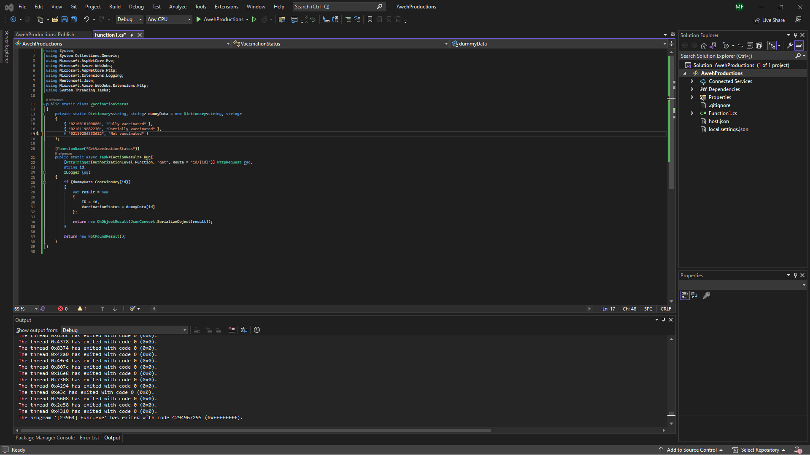

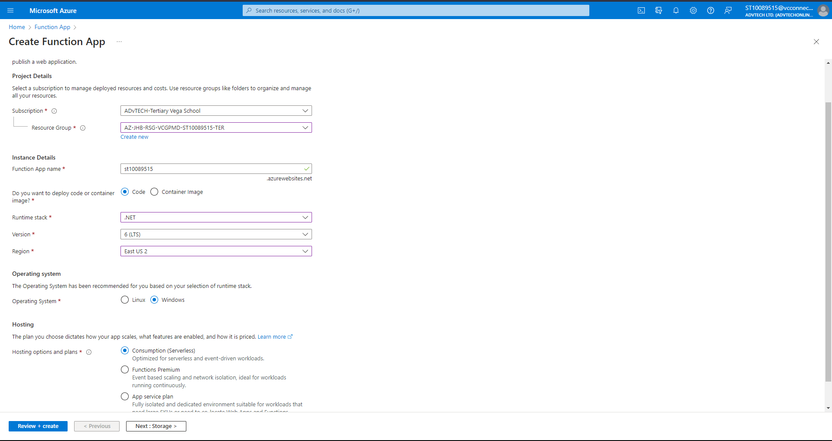

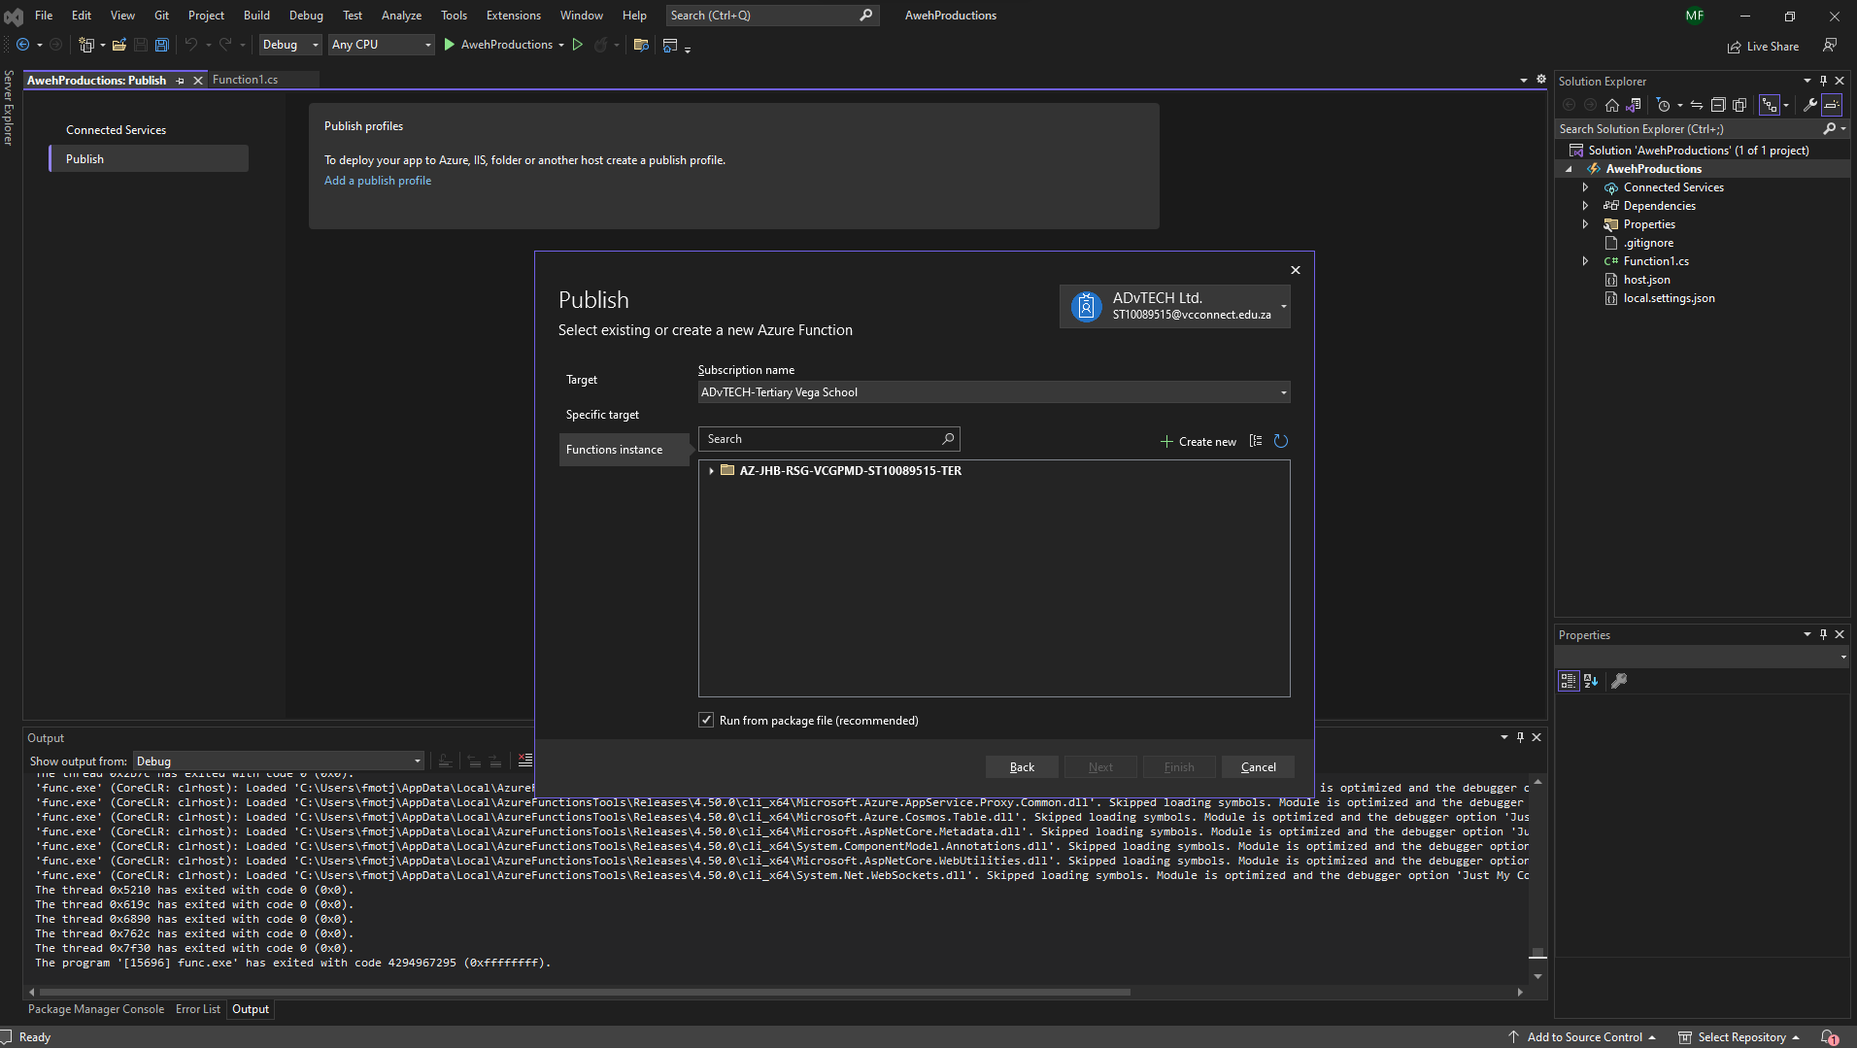

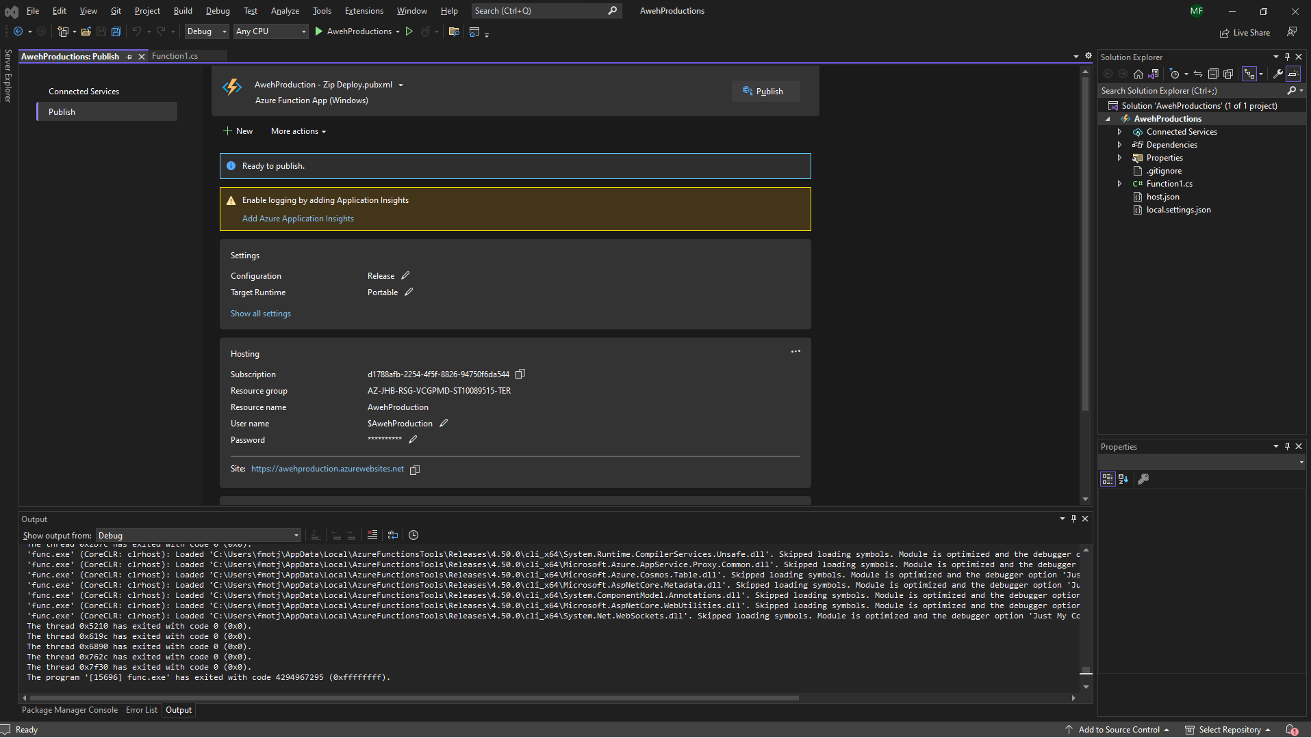

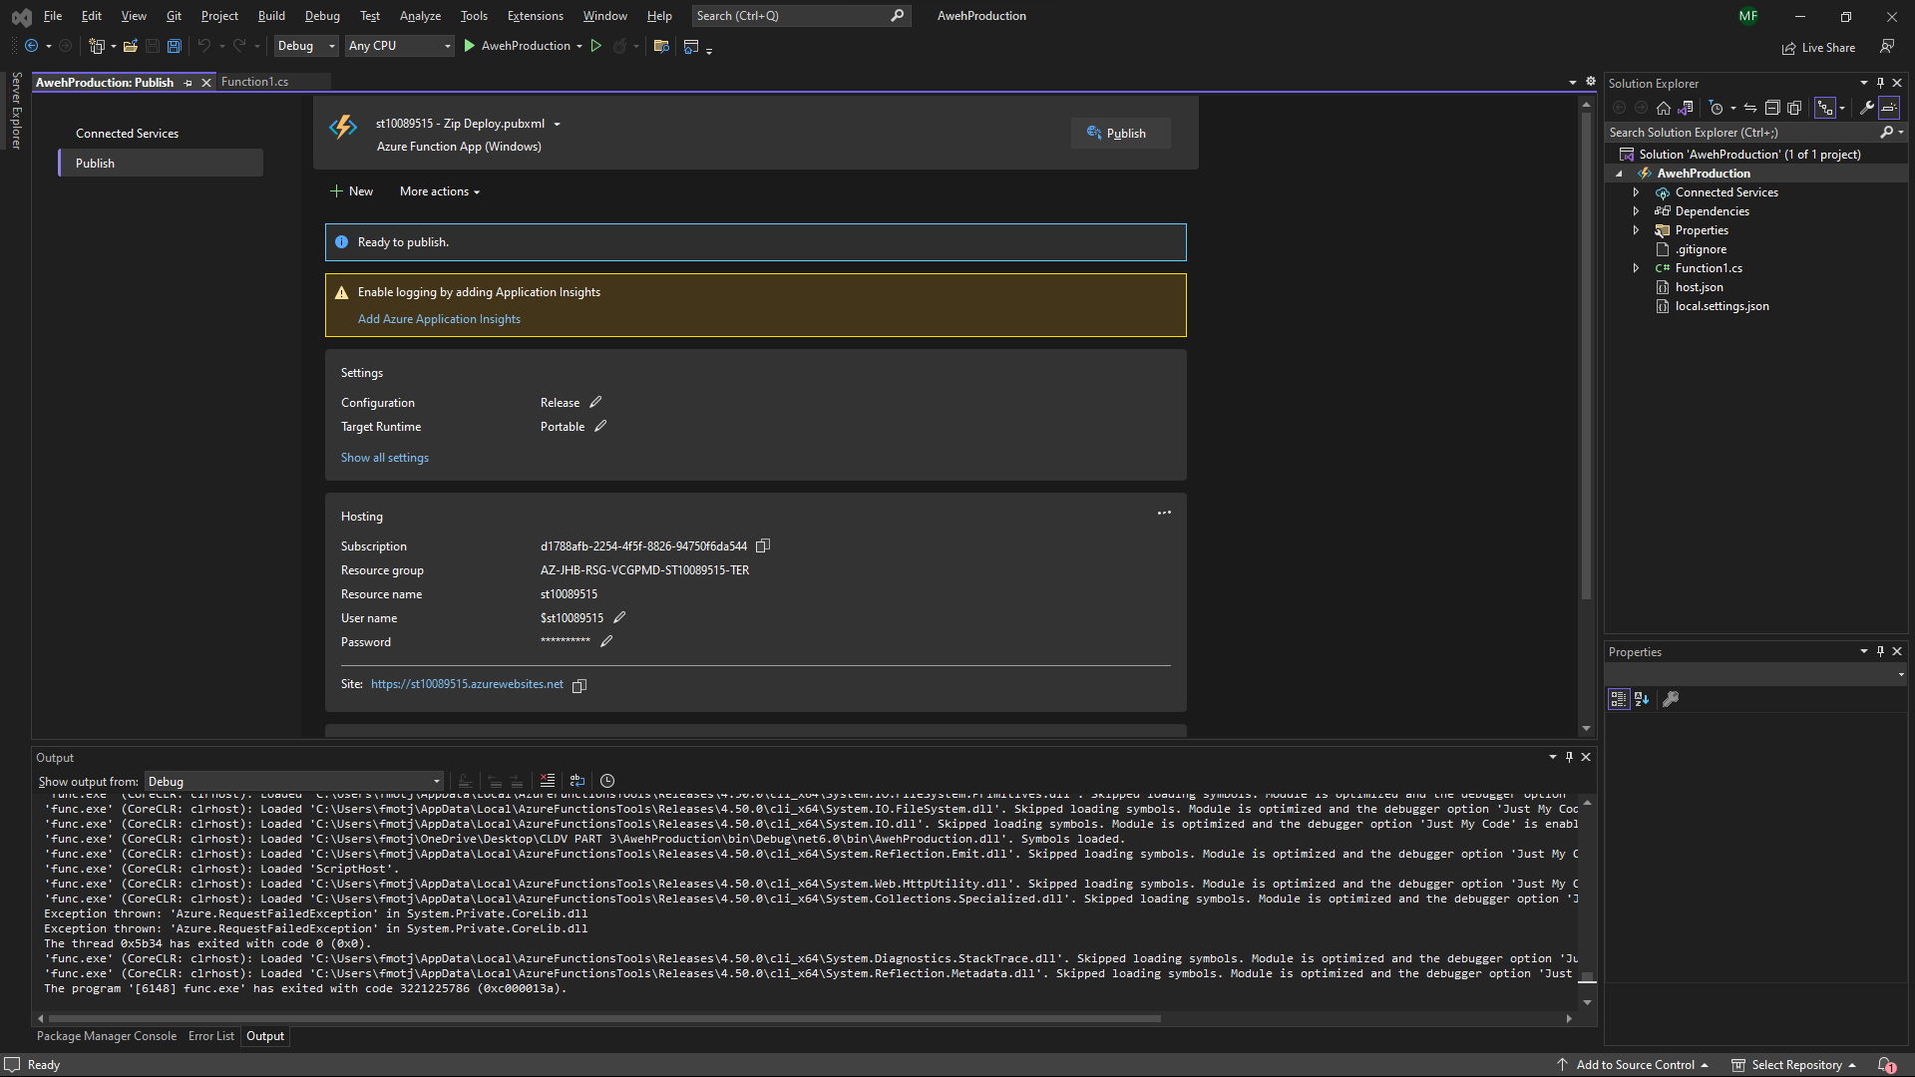

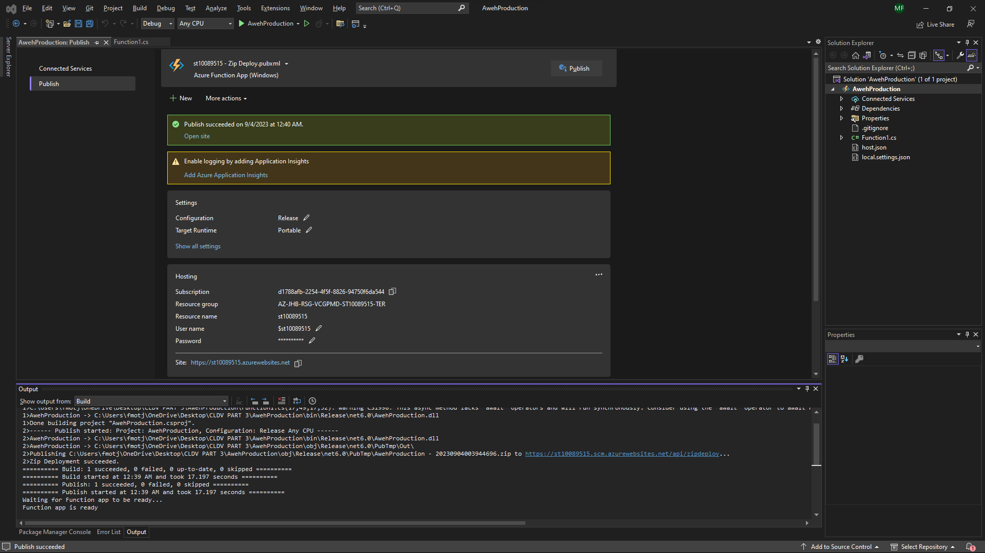

Evidence of Web Application.

ADDITIONAL NOTES

LIVE LINK:

[https://st10089515.azurewebsites.net/api/api/id/*************?code=wHJeHPDEzL7upVwPec5l8CfdXkBzY8IS0blVWHoWtBEsAzFuprLzww==](https://st10089515.azurewebsites.net/api/api/id/*************?code=wHJeHPDEzL7upVwPec5l8CfdXkBzY8IS0blVWHoWtBEsAzFuprLzww==)

PLACE HOLDER VALUES (SWAP THE ASTRICS LINE ABOVE WITH THE FOLLOWING):

0210015109080

7112365012563

2112030505051

Reference:

Amazon, n.d. What is an Event-Driven Architecture?. [Online] .Available at: [https://aws.amazon.com/event-driven-architecture/#:~:text=An%20event%2Ddriven%20architecture%20uses,on%20an%20e%2Dcommerce%20website](https://aws.amazon.com/event-driven-architecture/). [Accessed 2 September 2023].

cassandrad, 2017 . Data Driven vs Event Driven model/architecture?. [Online]. Available at: <https://stackoverflow.com/questions/42174856/data-driven-vs-event-driven-model-architecture> .[Accessed 1 September 2023].

Fonzi, B., 2023. Choosing between Data and Event-Driven Architecture. [Online]. Available at: <https://www.linkedin.com/pulse/choosing-between-data-event-driven-architecture-bruno-fonzi/> .[Accessed 3 September 2023].

Sommerville, I., 2016. Software Engineering. 10th ed. Boston: Pearson Education.

Vaughan, J., n.d. data. [Online]. Available at: [https://www.techtarget.com/searchdatamanagement/definition/data#:~:text=In%20computing%2C%20data%20is%20information,subject%20or%20a%20plural%20subject](https://www.techtarget.com/searchdatamanagement/definition/data). [Accessed 2 September 2023].

Microsoft. (2022). Azure Virtual Machines documentation. Microsoft Azure. https://docs.microsoft.com/en-us/azure/virtual-machines/ [Accessed 2 September 2023].

Smith, J. (2021). Best Practices for Azure Blob Storage. Microsoft Azure. https://azure.microsoft.com/en-us/resources/whitepapers/ [Accessed 25 August 2023].

Microsoft. (2023). Azure SQL Database documentation. Microsoft Azure. https://docs.microsoft.com/en-us/azure/sql-database/ [Accessed 27 August 2023].

Microsoft. (2022). Azure Active Directory documentation. Microsoft Azure. https://docs.microsoft.com/en-us/azure/active-directory/ [Accessed 27 August 2023].

Microsoft. (2021). Azure Functions documentation. Microsoft Azure. https://docs.microsoft.com/en-us/azure/azure-functions/ [Accessed 27 August 2023].